TO FIND RESOURCE
INFORMATION PLEASE
REFER TO THE
FOLLOWING LINKS

www.bgco.org/addictions
www.bgco.org/job assistance
www.bgco.org/prison ministry

Baptist General Convention
of Oklahoma
3800 N. May Avenue
Oklahoma City OK 73112

Paul Bettis, Chaplaincy Specialist
405-942-3800 Ext. 4304 or 4326
www.bgco.org/chaplaincy

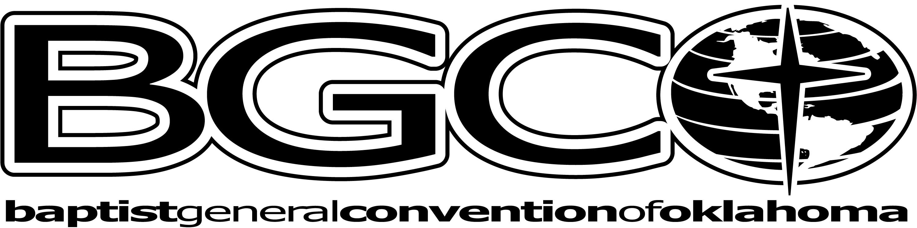

The chaplaincy ministry is made
possible by Oklahoma Baptists gifts through the Cooperative Program.
The chaplaincy ministry is made
possible by Oklahoma Baptists gifts through the Cooperative Program.

Eddie K. Coast
Criminal Justice Coordinator
Chaplaincy Ministries

Baptist General Convention of Oklahoma

405-990-3430
eddiecoast@hotmail.com

ADDICTIONS

What’s going on with these people?

Addiction Leads To
Marital problems, financial difficulties, and legal issues
Unstable home for children
55% of grandparents are raising their grandchildren.
Siblings are raising nieces and nephews.

Addiction knows no boundaries, it has many forms; and can go unnoticed.

CHAT ROOM INFIDELITY
Chat rooms are easy and convenient. You meet a lot of nice people in a chat room, but there are serious issues to think about. Many unhappy spouses try to meet their new internet friend who infatuates them. The internet makes cheating on your spouse a lot more convenient.
Unfortunately, after a brief encounter with their NEW LOVE, many return home to ANNOUNCE their divorce or short lived affair. Either way, it is disastrous for a family. Online infidelity is one of the leading causes of divorce.
For young people who use chat rooms, it’s about being honest with your parents about what is going on in your life.

ONLINE
PORNOGRAPHY
It’s a dirty little
Secret...or is it.

There are over 400,000 pornography websites on the internet! Adults, youth, and even senior adults report they have problems with this issue.
Good software, accountability of checking each family member’s computer use by their spouse or parent, and a good computer tech may be your best options for Issues involving a computer and the family. You need to be checking what is going on with each person in your family. The welfare of your family depends upon it.
Most porn addicts are blind to the harmful effects their behavior has on others.

OKLAHOMA
GAMBLING
Going to college has more challenges than it did in times past. Gambling, alcohol and drugs are more readily available. A student is given Casino incentives such as free vouchers for gambling. This starts out harmless enough. They plan to spend only the free money voucher, but greed leads to more spending and soon they realize they have lost all of their money. How is your college student doing with their personal finances and grades?
Money that should go for food, utilities, clothing and gasoline often finds its way into a dead end street called GAMBLING. Senior adults are often deceived by the lure of getting a big win. One out of four people in the United States believe that the lottery is a viable method of retirement. Is that why this same group of people are usually BROKE?

Each compulsive gambler costs the economy between $14,006 and $22,077 per year, or each tax payer an additional $280—$440 a year.
The recent Oklahoma gambling incentives have produced an overwhelming burden on resources usually reserved for those in crisis. In 2007, Oklahoma had 9 Federally Declared Disasters that were of NATURAL causes. The financial devastation caused by the Lottery and the Casinos are man made issues.
GAMBLING ISSUES CAN LEAD TO CRIME
In their mind, they were borrowing the money from the company where they worked. They were going to pay it back before anyone noticed it was missing. No one noticed, so they did it again. Then they devised a scheme to get more money. They have now become an embezzler. It is now a felony. This is a common story these days. The crime of embezzlement has risen in Oklahoma due in large part to gambling or other addictions.

ALCOHOL AND DRUG ADDICTION
The common consensus by most Americans is that alcohol isn’t as bad as other drugs. One half of American’s adult population consumes alcohol on a regular basis. Alcohol is the cause of more deaths than all illegal drugs combined. Alcohol kills 6 times more young people than all illicit drugs. It is the major factor in the 3 leading causes of death for youth: suicide, motor vehicle crashes, and homicide. Alcohol is linked to 2/3 of all sexual assaults and date rapes. One fifth of sexually active young people engage in unprotected sex while intoxicated. Alcohol is the number one drug problem young people experience and usually precedes the use of illegal drugs. Alcohol and drug addiction leads to mental health issues. One fourth who are incarcerated in prison should be in a mental health facility. Eighty six percent of teens who smoke pot start at or before age 15; the average being 13 ½ years old.

HOW TO HELP
AN ADDICT
They have legal issues and may need:
Power of Attorney
Physicians Directive
Living Will
This enables their family to help them when they are mentally impaired. Actually, we all need them so we can be prepared in times of crisis.
What kind of treatment can we consider…..
No Cost Services
- Christian 12-Step
- Alcoholics Anonymous
- Narcotics Anonymous
- Gamblers Anonymous
- Porn Addiction 12-Step
Professional
- State and private treatment centers

WHAT CAN A CHURCH DO FOR AN ADDICT?
Survey of the Church:
Do we have a need?
Survey of the Community:
What resources are available to help? Your County Oklahoma Department of Health and Human Services is a good place to start.

DEVELOP A PLAN
Minister to the family members of an addict... parents, children and spouse.
Minister to the Addicts that live in the area.
Invite them to participate in: Bible Study, Church Services, Sunday School, 12 Step Programs, and Family Ministries.
Minister to those in the local jail. Often times this is a wake up call to change their life.
Minister to those in local prisons or work centers.
Become a positive mentor.

The chaplaincy ministry is made
possible by Oklahoma Baptists gifts through the Cooperative Program.

